# **Check In #1 Summary**

The Gantt Chart and Product Backlog are attached in the folder submitted.

### **File 1: Client Signature Approval**

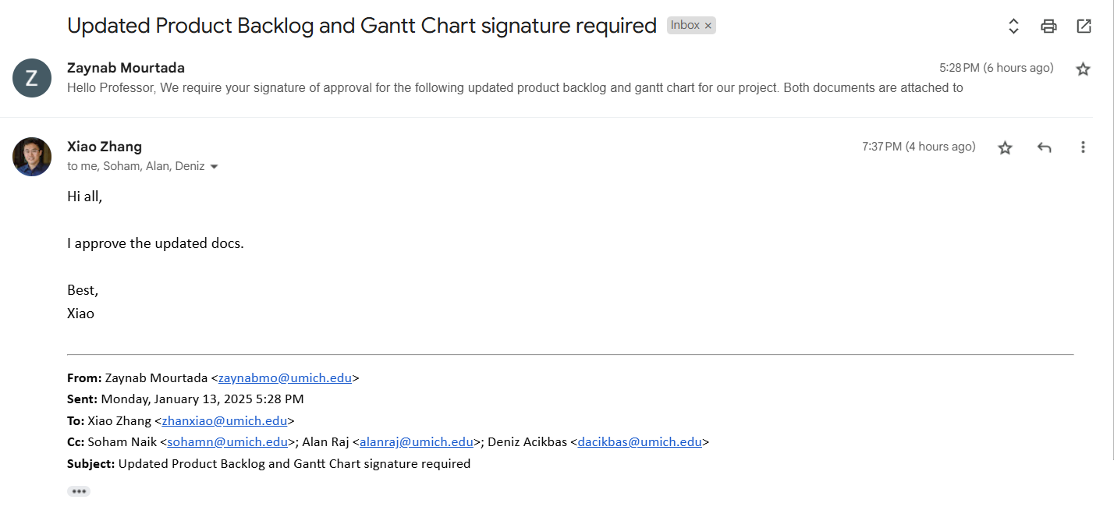

### **File 2: Gantt Chart**

The Gantt Chart is attached in the folder.

### **File 3: Product Backlog**

The Product Backlog is attached in the folder.